**PAYMENT METHOD-AZURE DEVOPS**

EPIC -PAYMENT

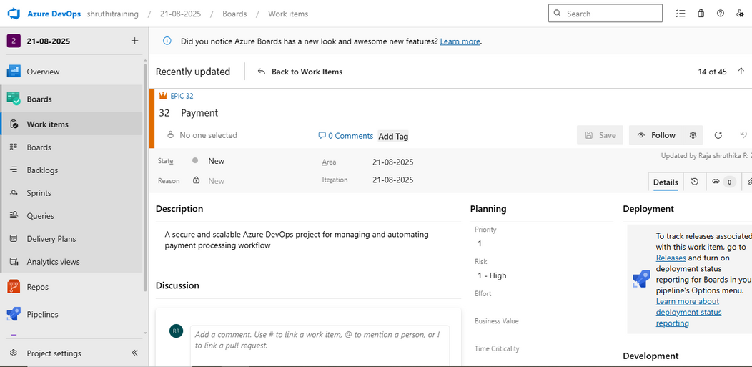

FEATURES -

CREDIT CARD PAYMENT

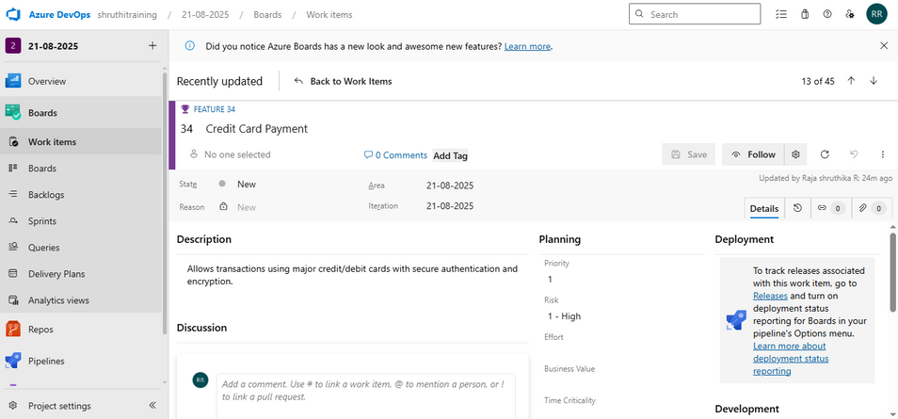

INTERNET BANKING

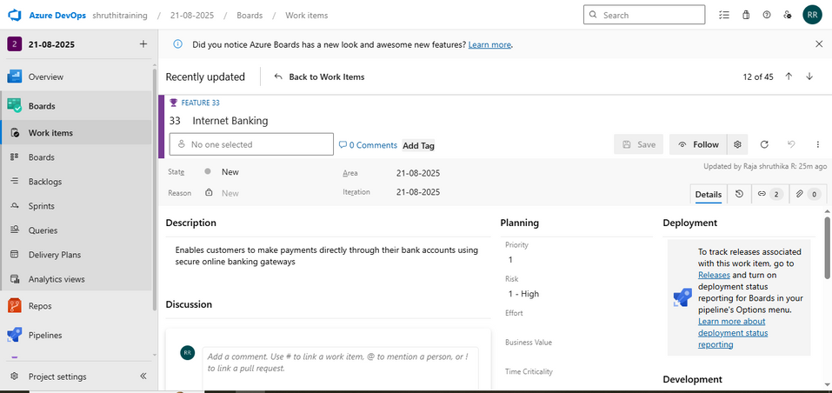

UPI

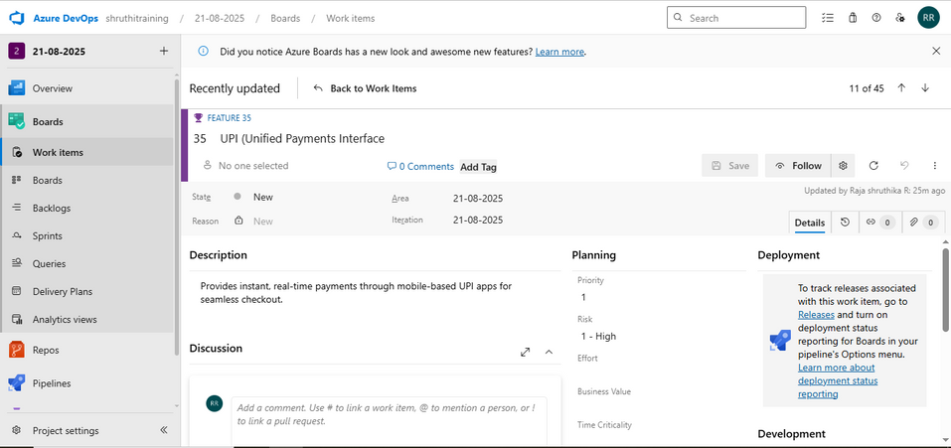

EMI

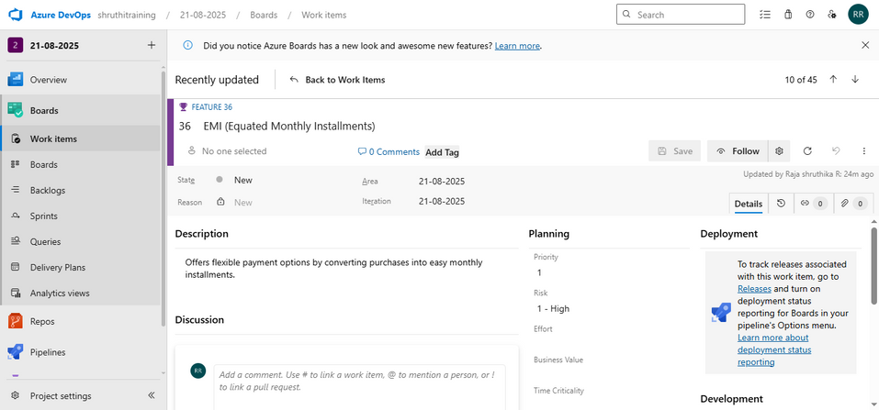

CASH ON DELIVERY(COD)

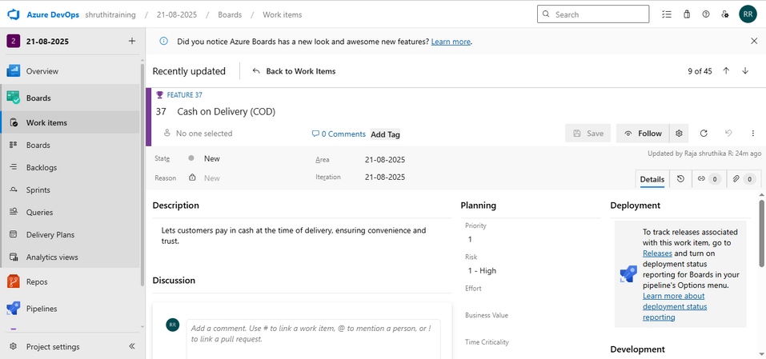

USER STORY

ICICI PAYMENT

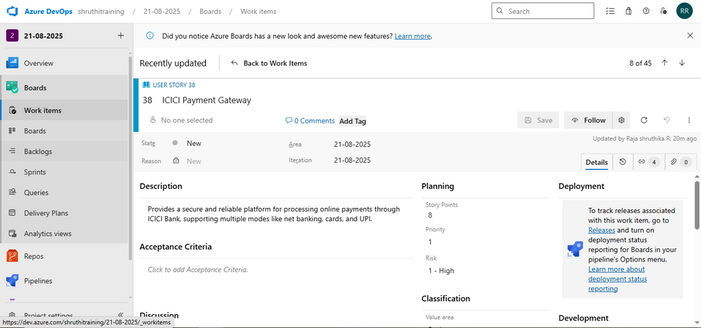

SBI PAYMENT

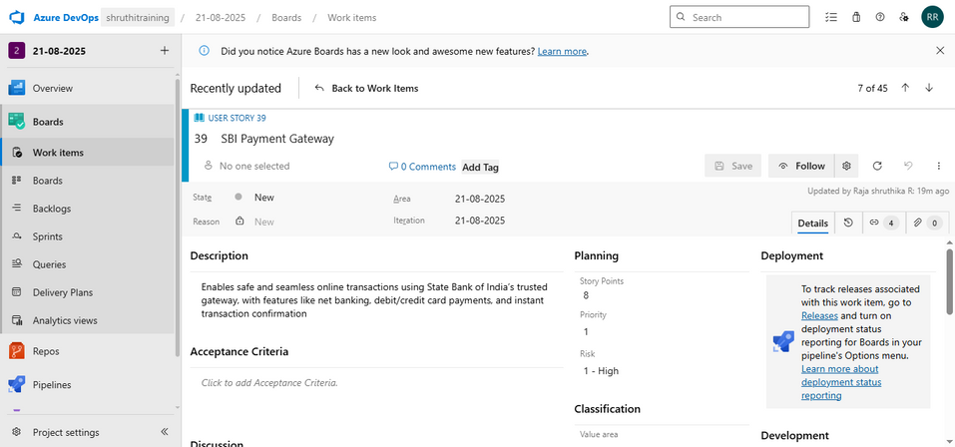

ICICI PAYMENT- INTERNET BANKING



SBI PAYMENT-INTERNET BANKING



TASK

AUTHENDICATION

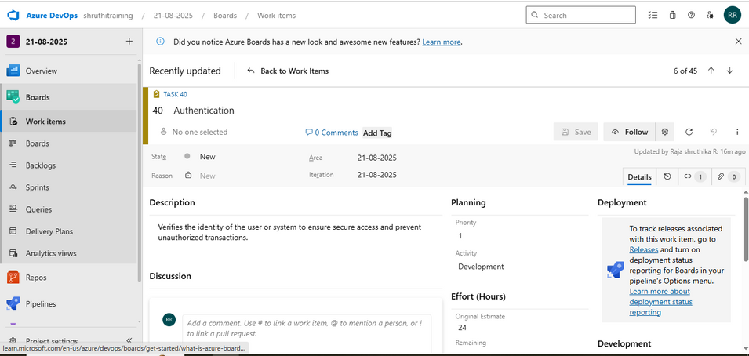

ACKNOWLEDGEMENTS

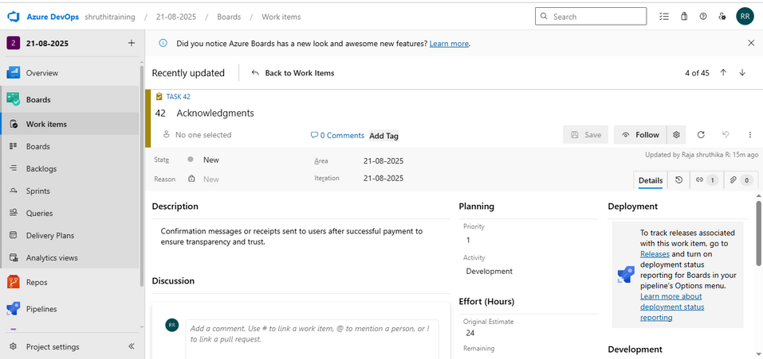

DIGITAL CERTIFICATE

